Problem 1

echo "Simple Calculator"

echo "Choose an operation:"

echo "1. Addition (+)"

echo "2. Subtraction (-)"

echo "3. Multiplication (*)"

echo "4. Division (/)"

read -p "Enter your choice (1-4): " choice

read -p "Enter first number: " num1

read -p "Enter second number: " num2

case $choice in

1. result=$(echo "$num1 + $num2" | bc)

echo "result: $result";;

1. result=$(echo "$num1 echo - $num2" | bc)

Echo “result: $result”;;

1. result=$(echo "$num1 * $num2" | bc)

echo "result: $result" ;;

1. if [ "$num2" -eq 0 ]; then

echo "error"

else

result=$(echo "scale=2; $num1 / $num2" | bc)

echo "result: $result" fi ;;

esac

output

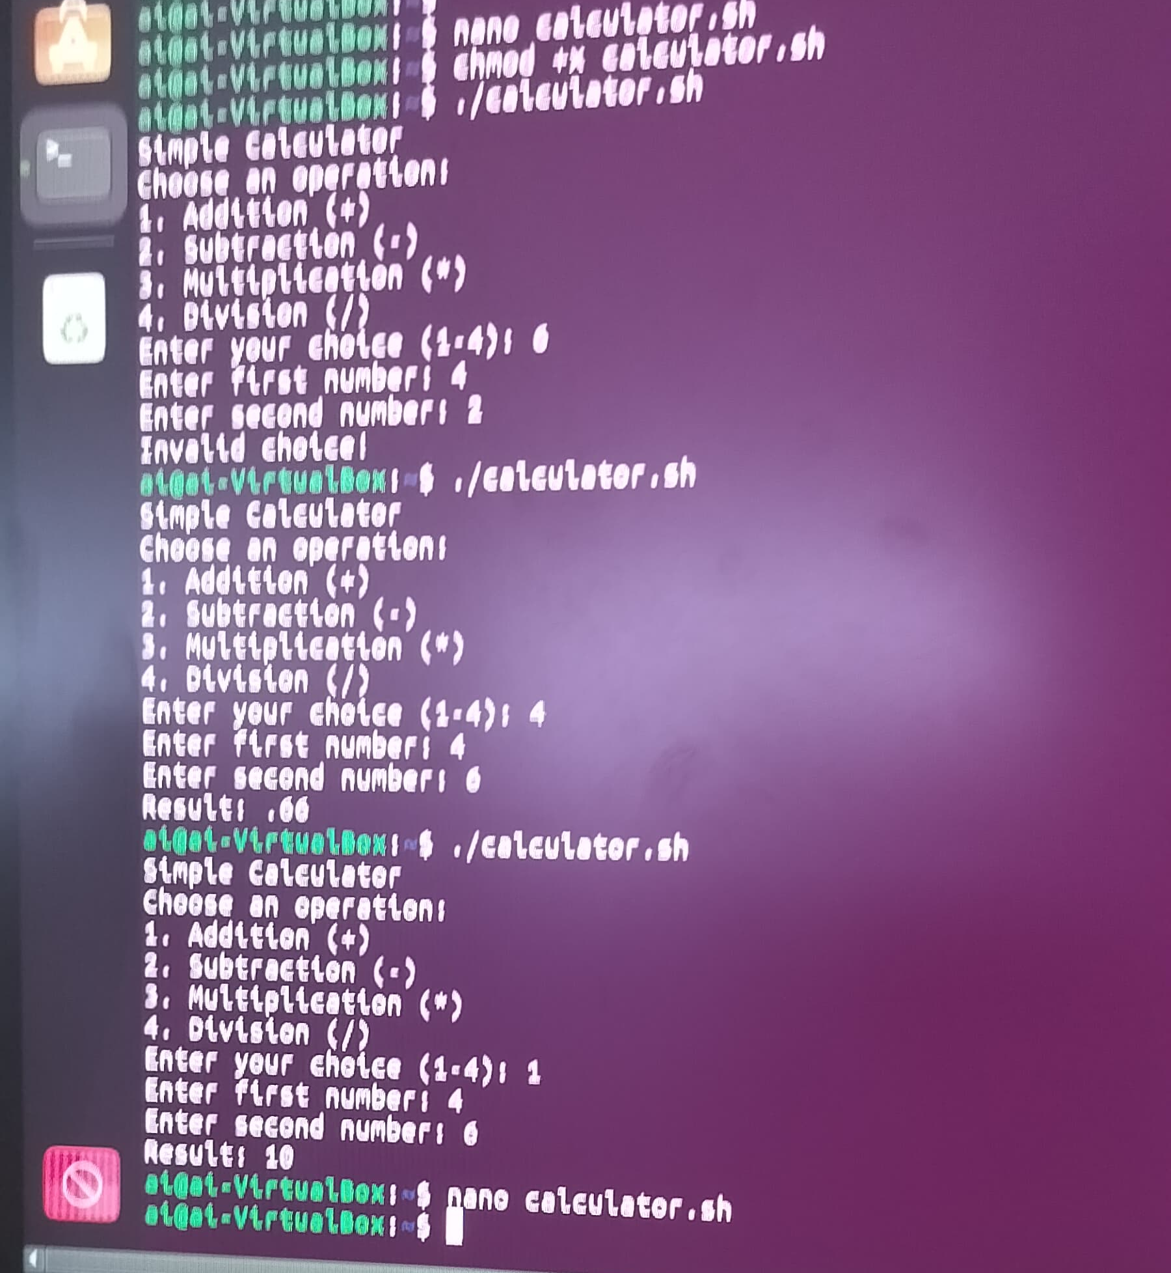

Problem 2

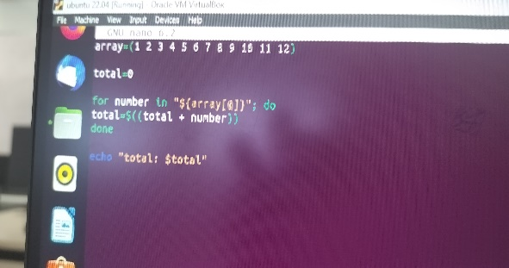array=(1 2 3 4 5 6 7 8 9 10 11 12)

total=0

for number in "${array[@]}"; do total=$((total + number))

done

echo "total: $total"

output



Problem 3

Head -p "enter string:" -a array

result=""

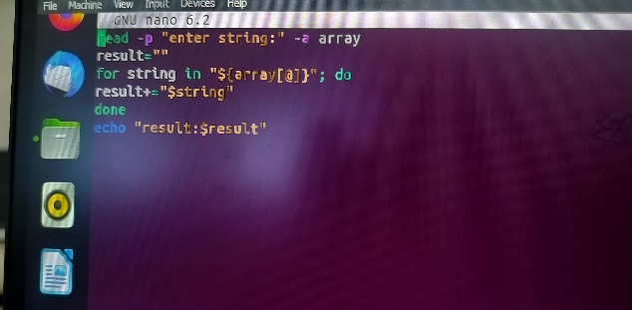

for string in "${array[@]}"; do

result+="$string"

done

echo "result: $result"

Output



Problem 4

echo "enter the file name " read filename

count=0

if [[ -f "$filename"]]; then

while IFS= read -r line; do

count=$((count+1))

done <"$filename"

else

echo "file is not there"

fi

echo "the number of lines in $filename is $count "

output

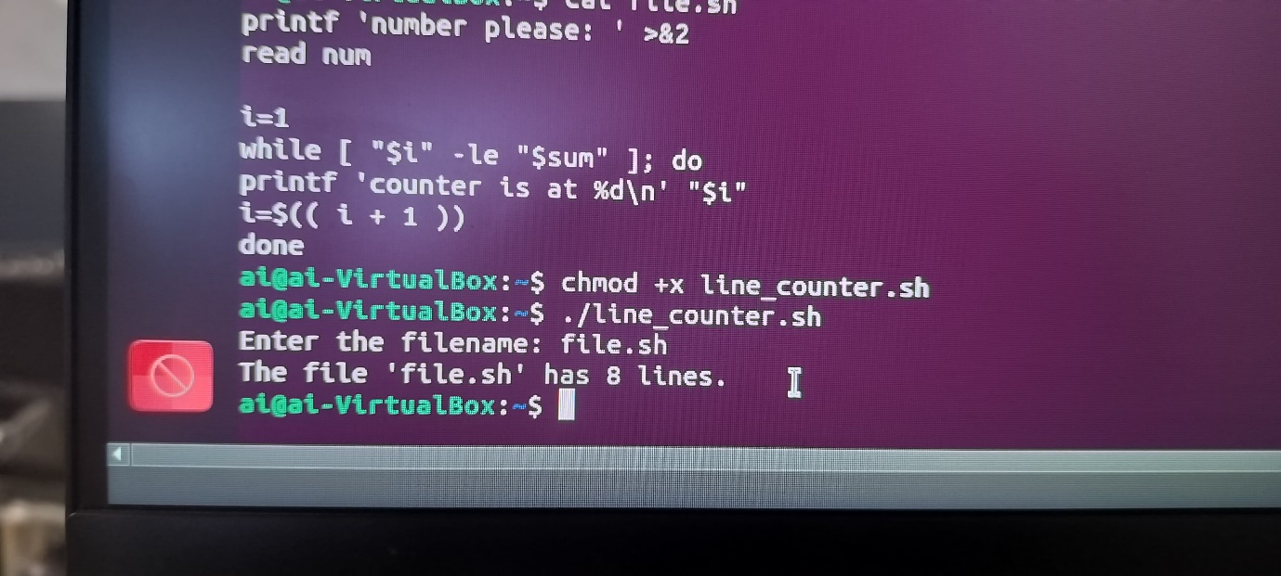

Problem 5

count_lines() {

local filename=$1

if [[-f $filename ]];

then

local line_count=$(wc -l < "$filename")

echo "$filename: $line_count lines"

return $line_count

else

echo “error”

return 0

fi

}

# main

read -p "enter filenames : " -a filenames

total_lines=0

for file in "${filenames[@]}"; do

line_count=$(count_lines "$file")

echo "$line_count"

if [[$-eq]]; then

lines_in_file=$(echo "$line_count" | awk '{print $2}')

total_lines=$((total_lines + lines_in_file))

fi

done

echo "total lines in all files: $total_lines”

output

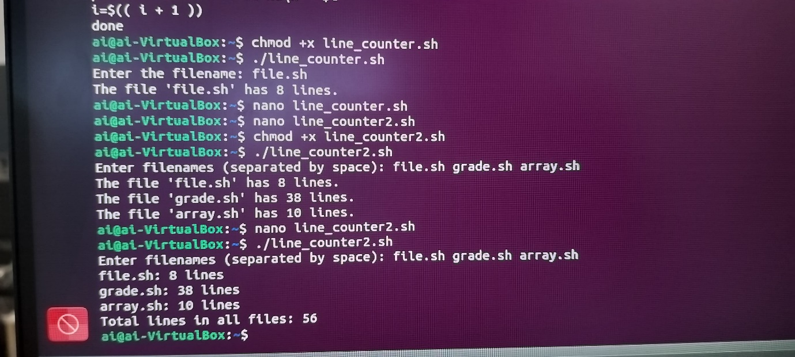

Problem 6

for input in*; do

if [[-d $input ]]; then

echo "$input is a directory."

if [[ -f "$input" ]]; then

echo "$input is a file."

else

echo "$input is not both"

fi

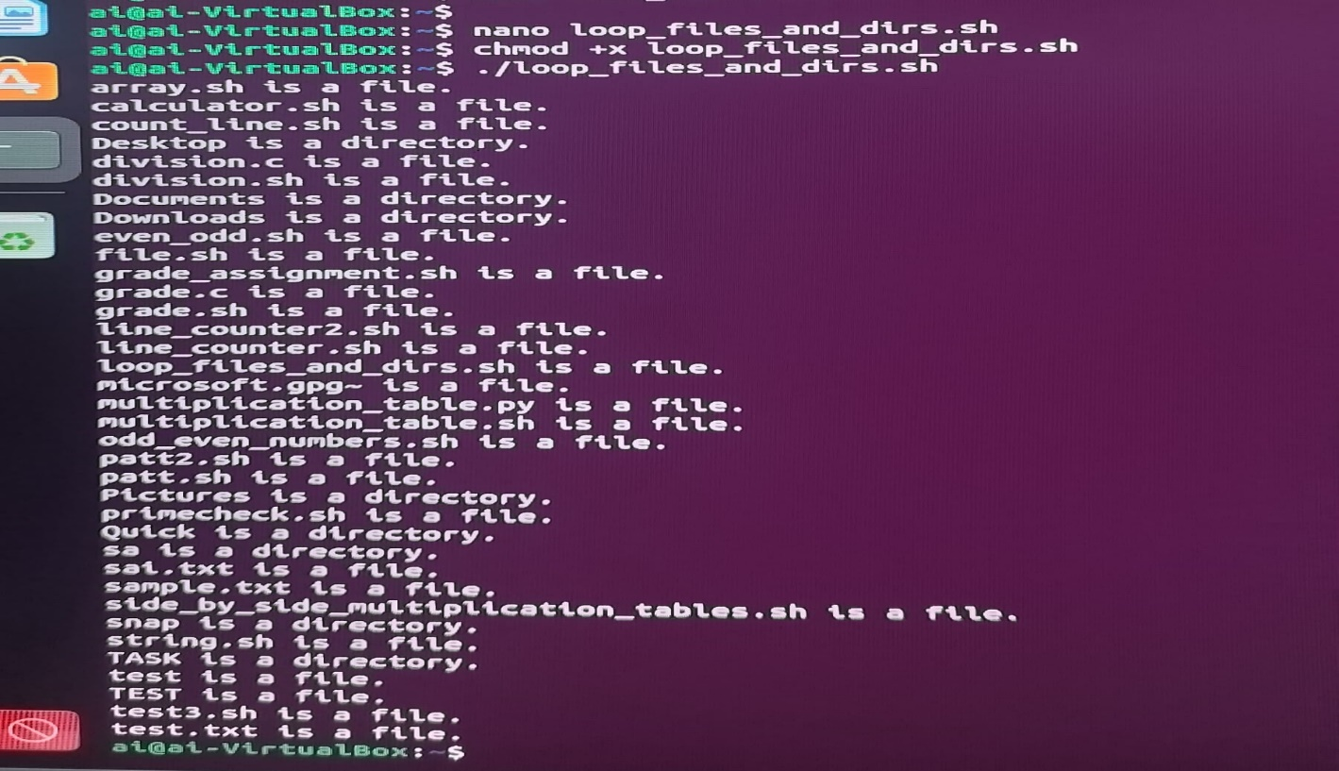esac